TiME TO LEAVE
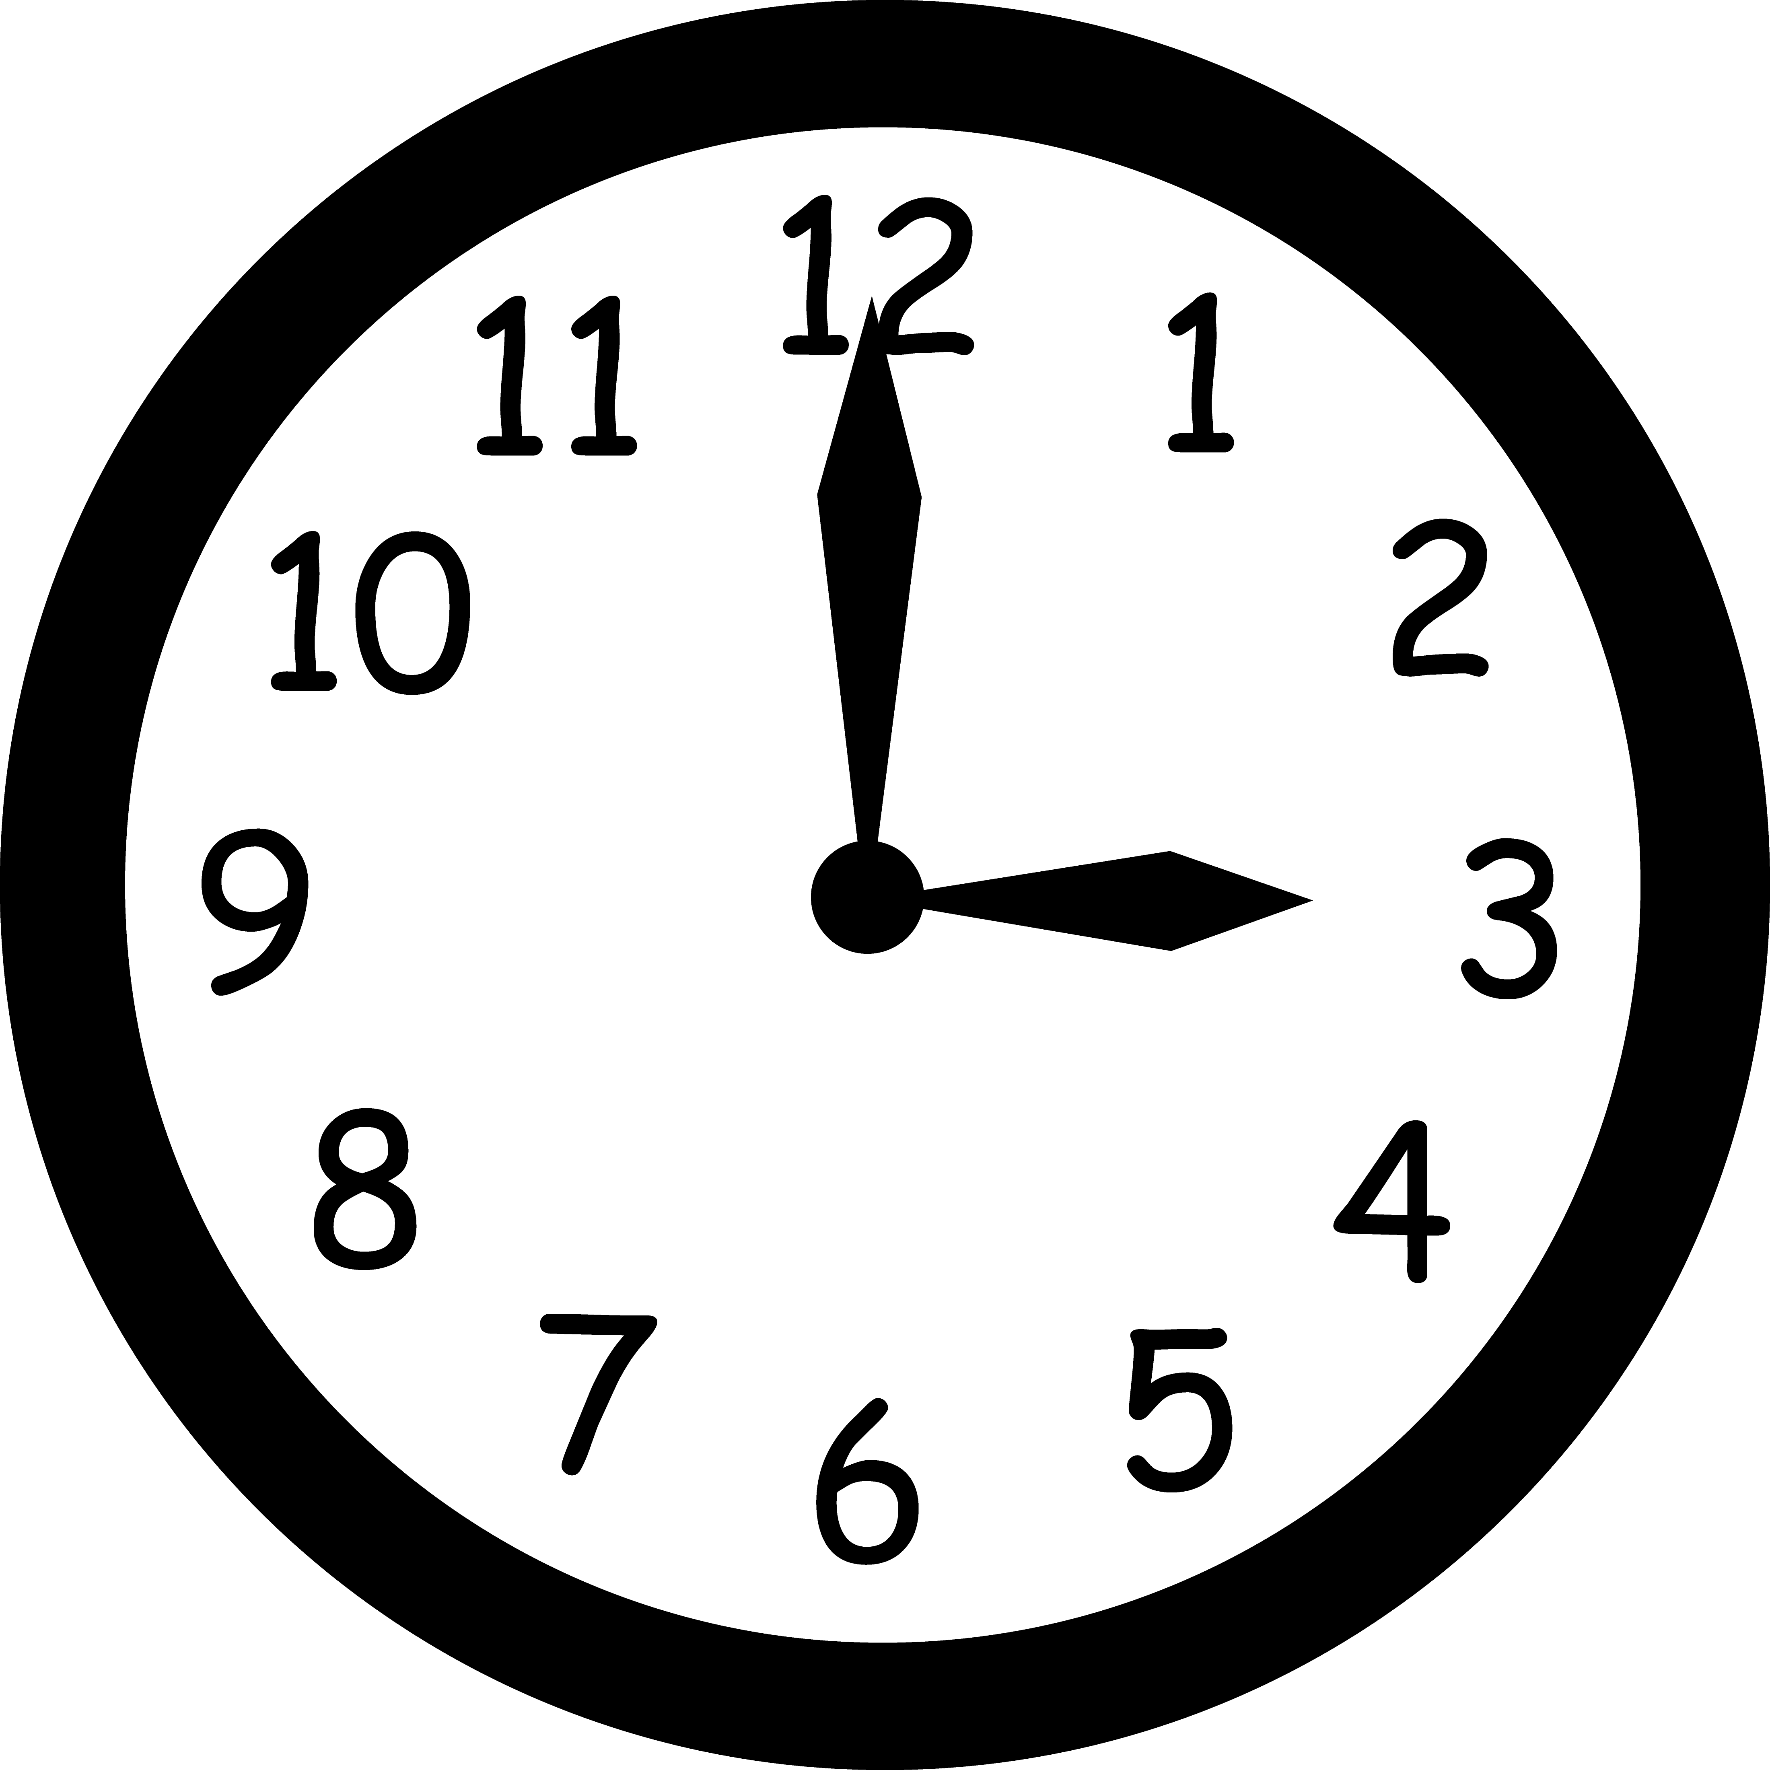

EAL new to English support to understand the activity

ENGLISH | POLISH | ARABIC
leave | pozostawiać | هجر
home | dom | حاجة
country | kraj | حاجة
take | wziąć | حمل
need | potrzeba | حاجة
want | chcieć | أراد

